Code

clc;

clear all;

a=-7;

b=7;

larr=[2 4 8];

deltaarr=[];

s=a+(b-a)*rand(1,10000);

m=[];

vp=[];

v=[];

SQNR_p=[];

SQNR=[];

fprintf("samples"+'\n');

disp(s(1,1:6));

for k=1:3

l=larr(k);

delta=(max(s)-min(s))/l;

%disp(delta);

delatarr(k)=delta;

st=-delta/2-(l/2-1)*(delta);

arr=[];

for i=1:l

arr(i)=st;

st=st+delta;

end;

% disp(arr);

snew=[];

for i=1:numel(s)

minimun=9;

ans=0;

for j=1:numel(arr)

if(abs(s(i)-arr(j))<=minimun)

minimun=abs(s(i)-arr(j));

ans=arr(j);

end;

end;

snew(i)=ans;

end;

fprintf("l="+larr(k)+'\n');

disp(snew(1,1:6));

m(k)=mean(abs(snew-s));

vp(k)=var(s-snew);

SQNR_p(k)=max(s)^2/vp(k);

end;

v= delatarr.^2/12;

SQNR=3*larr.^2;

figure(1);

stem(larr,m);

title("The mean absolute quantization error vs Number of Levels");

xlabel("Number of Levels");

ylabel("Mean absolute quantization error");

legend('The mean');

figure(2);

stem(larr,vp,'b');

title("The variance of the quantization error (Practical and Theoretical) vs the Number of levels");

xlabel("Number of Levels");

ylabel("Variance of the quantization error (Practical and Theoretical)");

hold on

stem(larr,v,'r');

legend('Practical var','Theoretical var');

hold off

figure(3);

stem(larr,SQNR_p,'b');

title("SQNR (Practical and Theoretical) vs the Number of levels");

xlabel("Number of Levels");

ylabel("SQNR (Practical and Theoretical)");

hold on

stem(larr,SQNR,'r');

legend('Practical SQNR','Theoretical SQNR');

Graphs

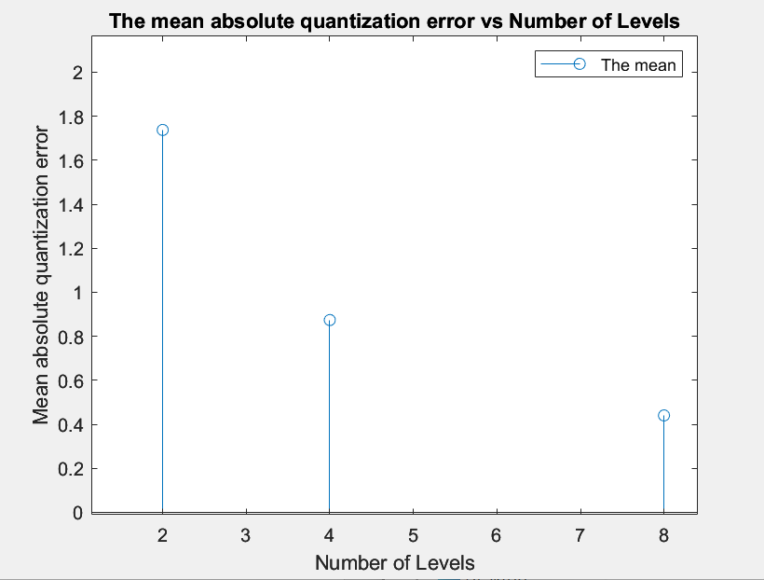

Comment: *after calculating the mean of the new sample, we*

*plotted a graph between number of levels and its corresponding mean, and as shown, as the number of levels increase the mean decrease which indicates more accuracy.*

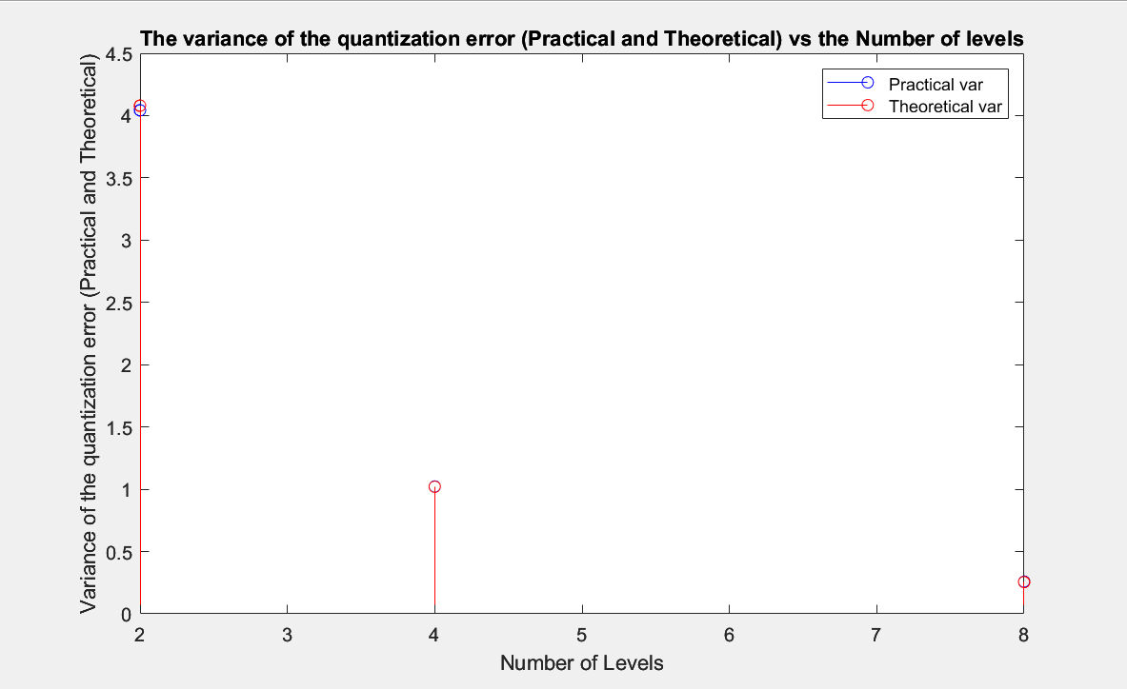

Comment: *after calculating the practical and theoretical variance, we plotted a graph between each one of them and the number of levels, and as shown they are almost the same.*

*Also, as the number of levels increase the variance decrease.*

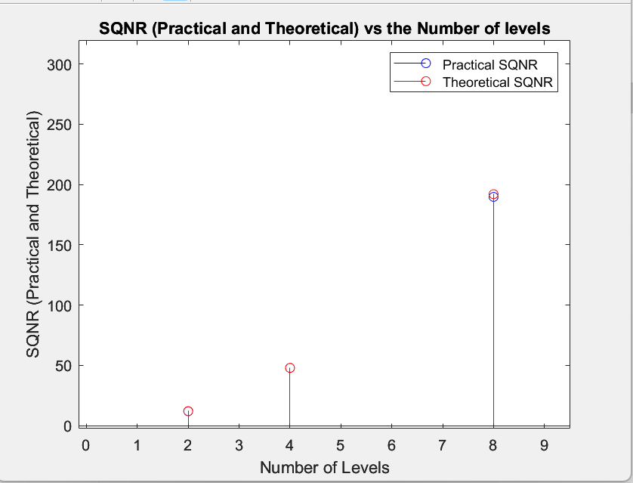

*Comment: This graph represents the relation between the Signal-to-Quantization Noise Ratio and the number of levels as the number of levels increase Signal-to-Quantization Noise Ratio increases.*